**HHT Lab**

1. **Goal of the HHT lab**

In the HHT lab, we're using HHT which has two main parts: EMD and Spectrum. The EMD part uses a special method called EEMD, which was made by Professor Huang. This method helps break down messy, unsteady data into simpler parts that we can understand better. The goal of the HHT process is to make the data easier to work with and understand. By transforming it, we can analyze it more efficiently and get more useful information from it than we could with the original messy data.

1. **screenshot of L1R1 result**

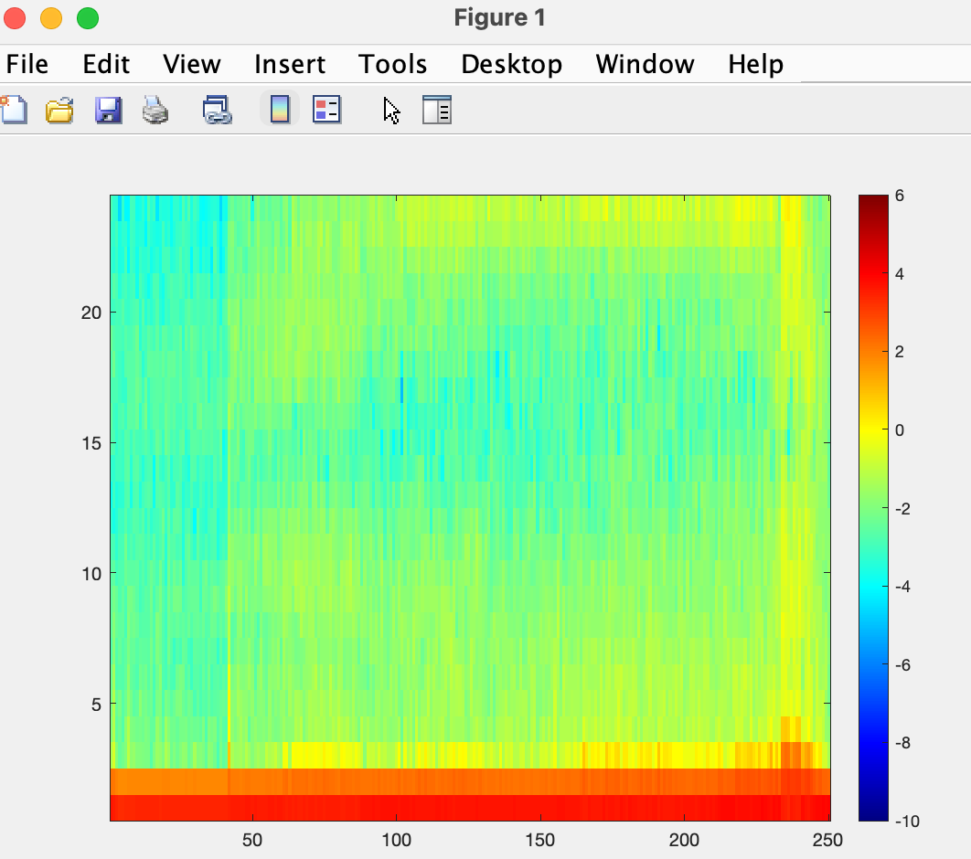

1. **screenshot of L1R0 result**

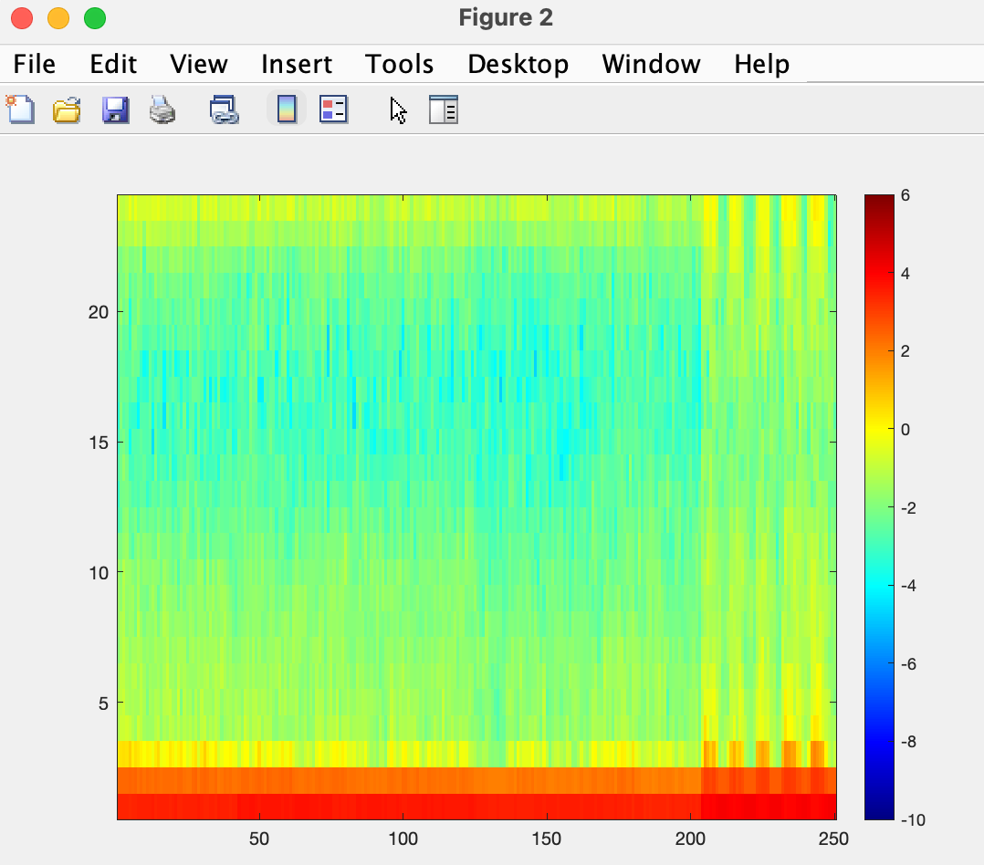

1. **analyze the difference between L1R1 and L1R0**

When we look at L1R1 and L1R0, we see they both have a lot of action happening at the lower frequencies (y-axis from 0 to 2.5). They seem pretty similar in how they perform, but if we compare them, L1R1 (on the left) has more yellow parts than L1R0. In this case, the different shades of yellow and green show how strong the vibrations are. This suggests that we might be able to spot more movements in L1R1 than in L1R0.



1. **what is beneficial about using HHT Spectrum**

Based on the PPT, the graphs represent the performance of analyzing raw data. The top line corresponds to L1R1, while the bottom line represents L1R0.

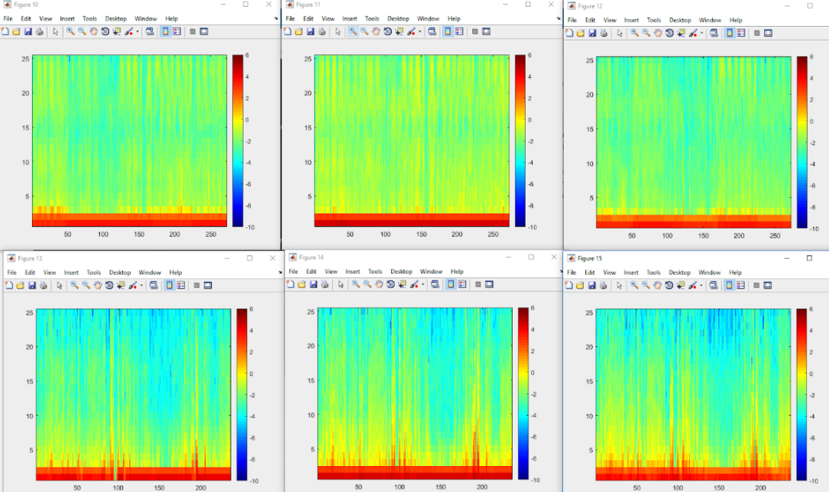

The graphs before and after using the HHT Spectrum process are noticeably different. Using the HHT Spectrum offers several benefits. It simplifies complex data, making patterns and trends easier to identify. The most significant change is in the complexity of the data. With the HHT Spectrum process applied, the data becomes clearer and more understandable. This clarity is crucial when we need to describe and interpret the features present in our data.